Name:_________________________

**Using the Light Sensor and Sounds - MakeCode**

**What you need:**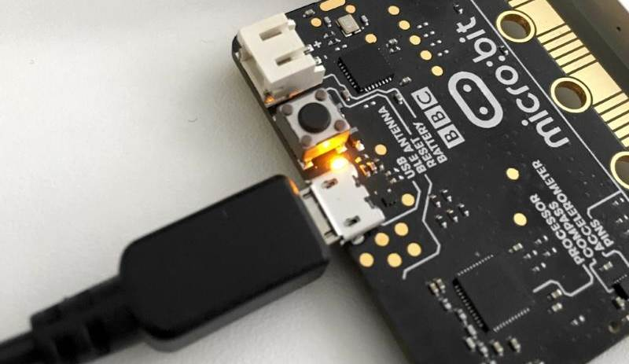

1. A computer with a USB port
2. V2.0 micro:bit
3. USB cable

**Setup:**

1. Plug in your micro:bit with the USB cable. The small USB mircoB end goes to the micro:bit and the regular USB end goes to the computer.
2. In a browser, go to <https://makecode.microbit.org/>. This is where you will program your micro:bit.
3. Click on ‘New Project’
4. You can name your project whatever you want, but you should name it based on the title of the lab. In this case, ‘Light Sensor and Sounds’

**Instructions:**

1. Inside the **forever** code block, we will use an **if** block from the **Logic** tab. This code block will execute whatever code is inside it when the statement we give it becomes true.

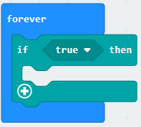

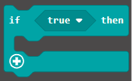

1. Inside the **if** code block, we need to change the condition of when the if statement becomes true. We will change it to when the micro:bit detects if the light shined on the light sensor is over a certain value. To do this, we first need to change the **True** statement to a numerical comparison. Drag the **two value greater than/less than** block from the **Logic** tab to the **True** statement in the if block.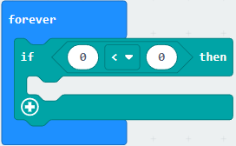



1. To get the current value of the light sensor for this comparison, drag the **light level** block from the **Input** tab to the right number field of the comparison block we just added in the previous step. Change the value on the right to 200 and the symbol to greater than (>).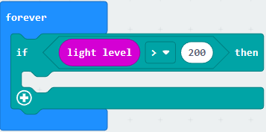



1. To have the micro:bit play a sound when the light sensor sees a bright light, we need to place a **play sound** code block from the **Music** tab, like the one we used in the beginner projects. Drag it into the **if** code block. You can pick whatever sound you want from the dropdown on the code block. In this case **giggle** was the sound used.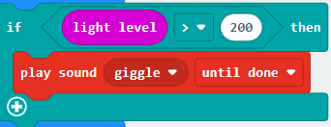



1. Click the **Download** button on the bottom on the bottom left hand side of the screen. This will upload your program to the micro:bit. When you shine a bright light at the micro:bit logo, does it play a sound?

**You Try It!**

Can you make the sensor more sensitive to different brightness levels of light?